Specification for PC Barcode

- System brief introduction
IDO -- I : Issue D : delivery O: Order
PC Barcode is a side program for warehouse to manage the daily jobs and communicate to ERP. In this system, we can do all the warehouse jobs, include goods receiving, material issuing, material returning, stock taking, printing labels, printing reports, etc., we can retrieve ERP data and update ERP database through ftp server.

- System functions and flowcharts
System Administration

PO Receive

Print

Labels
Retrieve data from ERP
Material Issue (IDO)
Update ERP Data
Material Return

Stock Take

(1). System Administration
This function is for setting system parameters and managing user profile. We will set the default ftp server, set next return no, set com port for scanner and manage the user’s profile
Begin
System setting (FTP server, Return batch no., HHT port)
User Profile
End (Save)

(2). PO Receiving
This function is for printing initial ids and final ids. We will retrieve HDO records from ERP, print initial labels, print final labels and print labels according to some conditions
ERP HDO Records
PC Barcode
Labels
Reports
Initial Label Print
Final Label Print
Report Print
APPI1U (Initial)
APPI2U (Final)

(3). Material Issuing
This function is for issuing material from stockroom to gate pass. We will retrieve data from IDO program according to some conditions, then scan the ids from stockroom and issue them, and then update ERP through ftp server

ERP Locked
IDO Side Program:[Ido1,Ido2]
PC Barcode
ERP Stock Records
Retrieve
Confirm
APPI3U

Scan
Report Print
Reports
HHT Records

Addition:IDO operation( generate IDO):
Add New IDO or Modify IDO that have not Confirmed on Ido1,select GatePass, select Material add to ido2 filter by Ido1.bh,and can modify the Quantity which IDO have not comfirmed, after done it ,then Comfirm the IDO,Only the have Confirmed IDO can Import to Material Issuing[PB_ GATEPASS].
(4). Material Returning
This function is for returning material from WIP to stockroom. There are 2 cases for material returning, 1 is for ids with label, one is for without label, for the first, we can scan the ids and then input to system, but for the second, we must input the ids manually, then update the returning qty and then update ERP through ftp server
ERP Stock Records
With Label?
Begin

PC Barcode
(No)
Manually Insert
APPI4U
Yes
HHT Records
Scan
Reports
Report Print

(5). Stock Taking
This function is for stock taking. We will retrieve count sheet from ERP, then scan the ids and input to the system, update the counted qty and then update ERP through ftp server.
ERP Count Sheet
PC Barcode
ERP Stock Records
APPI5U
APPI6U

Report Print
Reports
Scan

HHT Records

- Interface files for communication with ERP
(1). APPI1U (HDO records): Retrieve data from ERP
FIELD NAME | TYPE | LENGTH
Company Code | 字元 | 2
HDO Number | 字元 | 8
Stockroom Code | 字元 | 2
Item Code | 字元 | 15
Lot Number | 字元 | 15
Original Receipt Qty | 浮點數 | 整數部份：8  小數部份：3
Current Balance | 浮點數 | 整數部份：8  小數部份：3
UoM | 字元 | 2
Number of Copies | 整數 | 2
Number of Rolls | 浮點數 | 整數部份：8  小數部份：3
Marker Width | 浮點數 | 整數部份：7  小數部份：4
Sub pack / UoM | 字元 | 2

(2). APPI2U (Final ID label): Retrieve data from ERP
FIELD NAME | TYPE | LENGTH
Company Code | 字元 | 2
HDO Number | 字元 | 8
Stockroom Code | 字元 | 2
Item Code | 字元 | 15
Lot Number | 字元 | 15
Original Receipt Qty | 浮點數 | 整數部份：8  小數部份：3
Current Balance | 浮點數 | 整數部份：8  小數部份：3
UoM | 字元 | 2
Number of Copies | 整數 | 2
Number of Rolls | 浮點數 | 整數部份：8  小數部份：3
Marker Width | 浮點數 | 整數部份：7  小數部份：4
Sub pack / UoM | 字元 | 2

(3). APPI3U (Material Issued: IDO): Update ERP
FIELD NAME | TYPE | LENGTH
Company Code | 字元 | 2
Work Order Number | 字元 | 7
Issue Date | 字元 | 7
Stockroom Code | 字元 | 2
Item Code | 字元 | 15
Lot Number | 字元 | 15
Issue Qty | 浮點數 | 整數部份：8  小數部份：3
UoM | 字元 | 2
Issue Type | 字元 | 1
Movement Reason | 字元 | 2

(4). APPI4U (Material Returned): Update ERP
FIELD NAME | TYPE | LENGTH
Company Code | 字元 | 2
Work Order Number | 字元 | 7
Return Date | 字元 | 7
Stockroom Code | 字元 | 2
Item Code | 字元 | 15
Lot Number | 字元 | 15
Return Qty | 浮點數 | 整數部份：8  小數部份：3
UoM | 字元 | 2

(5). APPI5U (Count sheet): Retrieve data from ERP
FIELD NAME | TYPE | LENGTH
Company Code | 字元 | 2
Count | 字元 | 7
Stockroom Code | 字元 | 2
Item Code | 字元 | 15
Lot Number | 字元 | 15
Computer Qty | 浮點數 | 整數部份：8  小數部份：3
UoM | 字元 | 2

(6). APPI6U (Count Detail): Update ERP
FIELD NAME | TYPE | LENGTH
Company Code | 字元 | 2
Stockroom Code | 字元 | 2
Item Code | 字元 | 15
Lot Number | 字元 | 15
Counted Qty | 浮點數 | 整數部份：8  小數部份：3
UoM | 字元 | 2

- Data structure
(1). System Administration:
PB_SYSTEM
FIELD | TYPE | LENGTH | IS NULL | KEY
FTPIP | VARCHAR | 15 | NO | NO
FTPPORT | VARCHAR | 1 | NO | NO
FTPUSER | VARCHAR | 10 | NO | NO
FTPPWD | VARCHAR | 10 | NO | NO
NEXT_RETURN_NO | VARCHAR | 10 | YES | NO
HHTPORT | VARCHAR | 1 | NO | NO

PB_USER
FIELD | TYPE | LENGTH | IS NULL | KEY
UID | VARCHAR | 10 | NO | YES
UPWD | VARCHAR | 10 | NO | NO
UR1 | BIT |  | NO | NO
UR2 | BIT |  | NO | NO
UR3 | BIT |  | NO | NO
UR4 | BIT |  | NO | NO
UR5 | BIT |  | NO | NO
UR6 | BIT |  | NO | NO
UR7 | BIT |  | NO | NO
UR8 | BIT |  | NO | NO
UR9 | BIT |  | NO | NO
UR10 | BIT |  | NO | NO

(2). PO Receive
PB_HDO
FIELD | TYPE | LENGTH | IS NULL | KEY
HDO_NO | VARCHAR | 8 | NO | YES
ITEM_CODE | VARCHAR | 15 | NO | YES
LOT_ID | VARCHAR | 15 | NO | YES
ORG_QTY | FLOAT |  | NO | NO
CUR_BAL | FLOAT |  | NO | NO
UOM | VARCHAR | 2 | NO | NO
STOCKROOM | VARCHAR | 2 | NO | YES
COMPANY | VARCHAR | 2 | NO | YES
NO_OF_COPIES | INTEGER |  | YES | NO
NO_OF_ROLLS | INTEGER |  | NO | NO
MARKER_WIDTH | FLOAT |  | YES | NO
PURCHASE_UOM | VARCHAR | 2 | NO | NO
STATUS | INTEGER |  | NO | NO
RECORD_CREATED_DATE | SMALLDATETIME |  | NO | NO

PB_FINALID
FIELD | TYPE | LENGTH | IS NULL | KEY
HDO_NO | VARCHAR | 8 | NO | YES
ITEM_CODE | VARCHAR | 15 | NO | YES
LOT_ID | VARCHAR | 15 | NO | YES
ORG_QTY | FLOAT |  | NO | NO
CUR_BAL | FLOAT |  | NO | NO
UOM | VARCHAR | 2 | NO | NO
STOCKROOM | VARCHAR | 2 | NO | YES
COMPANY | VARCHAR | 2 | NO | YES
NO_OF_COPIES | INTEGER |  | YES | NO
NO_OF_ROLLS | INTEGER |  | NO | NO
MARKER_WIDTH | FLOAT |  | YES | NO
PURCHASE_UOM | VARCHAR | 2 | NO | NO
STATUS | INTEGER |  | NO | NO
RECORD_CREATED_DATE | SMALLDATETIME |  | NO | NO

(3). Material Issue
PB_GATEPASS
FIELD | TYPE | LENGTH | IS NULL | KEY
SOP | VARCHAR | 7 | NO | YES
PROJECT_NO | VARCHAR | 20 | NO | NO
IDO | VARCHAR | 12 | NO | NO
WORK_ORDER | VARCHAR | 7 | NO | YES
LOT_ID | VARCHAR | 15 | NO | YES
ISSUE_QTY | FLOAT |  | NO | NO
GATEPASS | VARCHAR | 15 | NO | NO
UID | VARCHAR | 10 | NO | NO
ISSUED_DATE | DATETIME |  | NO | YES
UOM | VARCHAR | 2 | NO | NO

(4). Material Return
PB_RETURN
FIELD | TYPE | LENGTH | IS NULL | KEY
RETURN_NO | VARCHAR | 10 | NO | YES
ITEM_CODE | VARCHAR | 15 | NO | YES
WORK_ORDER | VARCHAR | 7 | NO | YES
LOT_ID | VARCHAR | 15 | NO | YES
RETURN_QTY | FLOAT |  | NO | NO
UOM | VARCHAR | 2 | NO | NO
RETURN_DATE | SMALLDATETIME |  | NO | NO
STOCKROOM | VARCHAR | 2 | NO | YES
COMPANY | VARCHAR | 2 | NO | YES
STATUS | INTEGER |  | NO | NO
RECORD_CREATED_DATE | SMALLDATETIME |  | NO | NO

(5). Stock Take
PB_COUNT
FIELD | TYPE | LENGTH | IS NULL | KEY
COUNT_NO | VARCHAR | 7 | NO | YES
ITEM_CODE | VARCHAR | 15 | NO | YES
LOT_ID | VARCHAR | 15 | NO | YES
COMPUTER_QTY | FLOAT |  | NO | NO
COUNTED_QTY | FLOAT |  | NO | NO
UOM | VARCHAR | 2 | NO | NO
STOCKROOM | VARCHAR | 2 | NO | YES
COMPANY | VARCHAR | 2 | NO | YES
COUNT_DATE | SMALLDATETIME |  | NO | NO
RANDOM_TAKE | BIT |  | NO | NO
STATUS | INTEGER |  | NO | NO
RECORD_CREATED_DATE | SMALLDATETIME |  | NO | NO

- Screens for PC Barcode (only for reference)
(1). System setting (Administration)
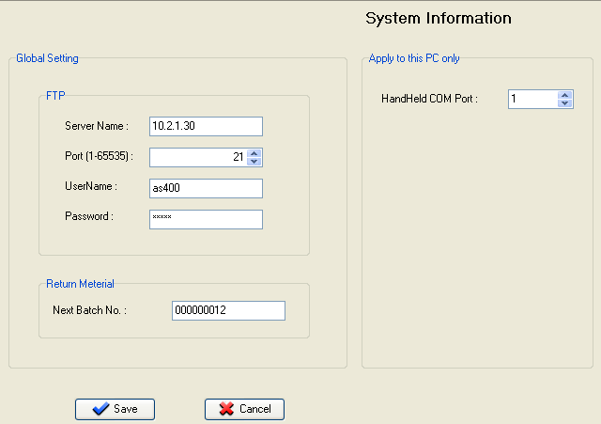

(2). Print label (final label)
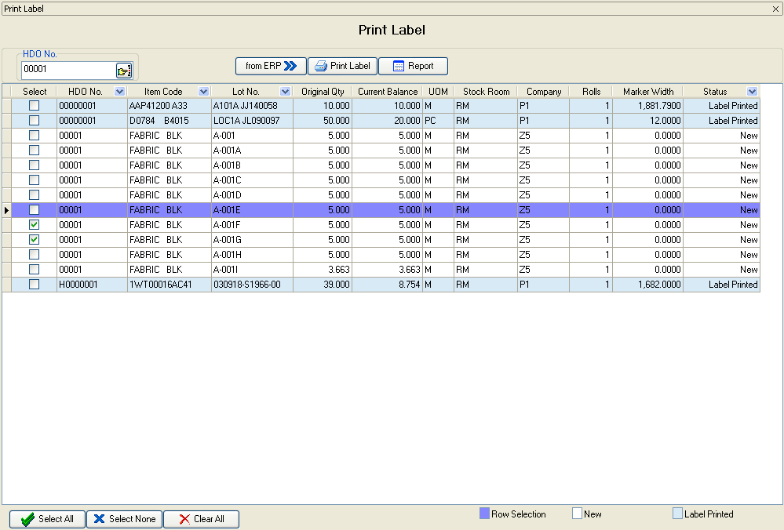

(3). Material issue (IDO)
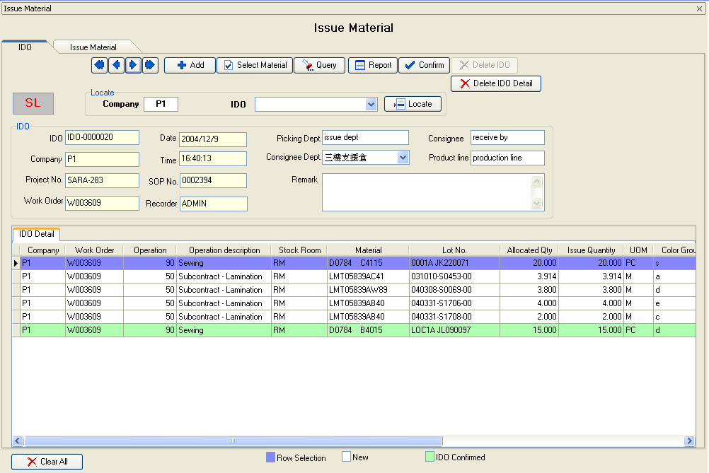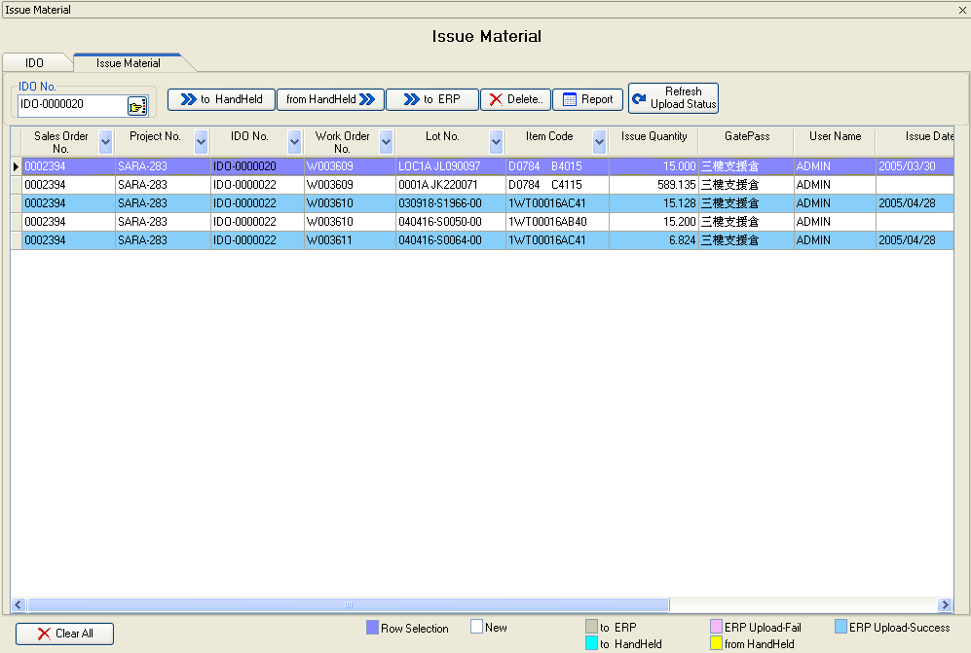

(4). Material Return
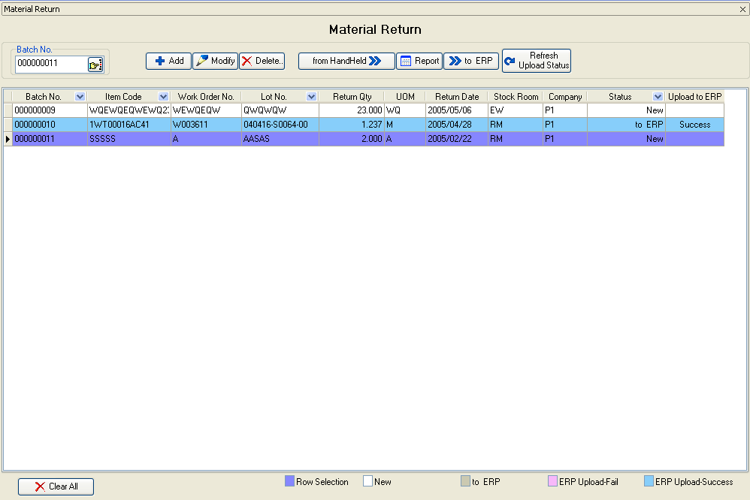
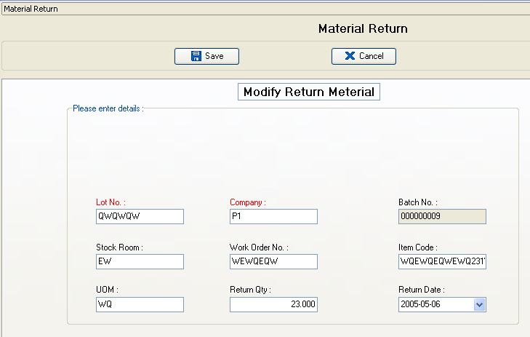

(5). Stock take
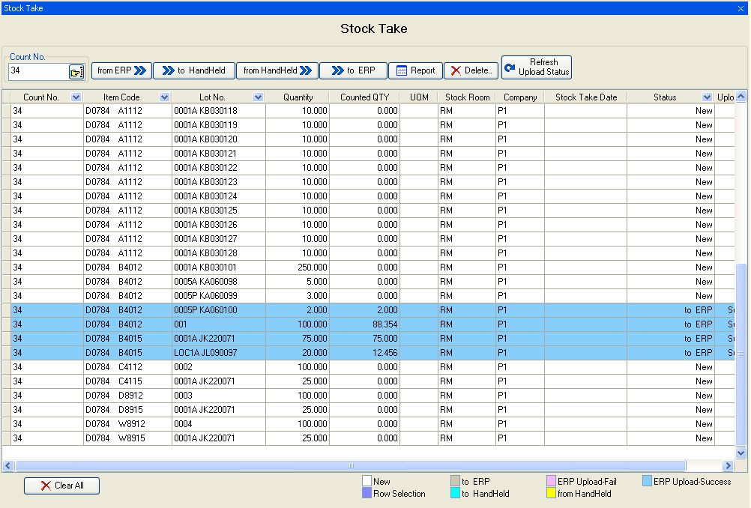

(6).User Admin(not use,has removed,see PBPower.exe)

(7) Login and MainForm
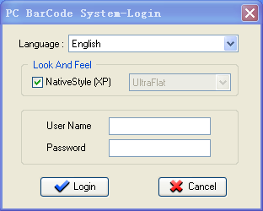
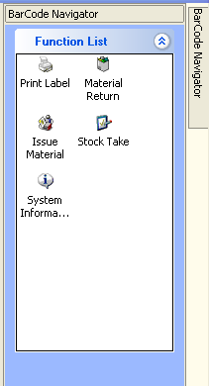.
- Reports format (only for reference)
(1). Report for initial label printing(not use)

(2). Material Issue (IDO)
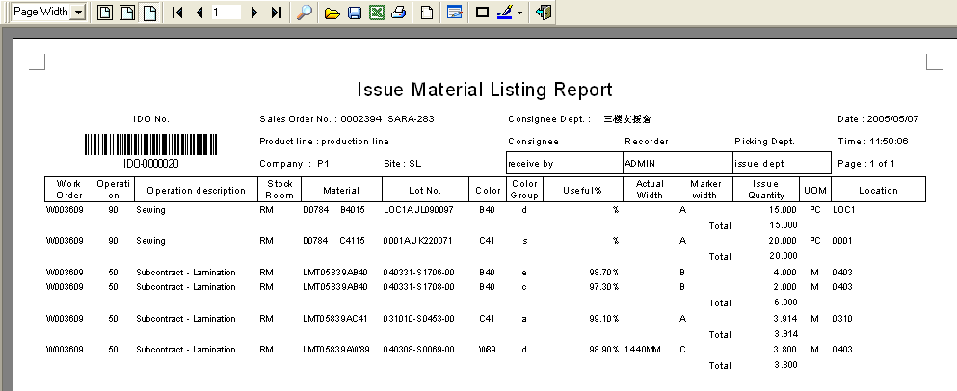
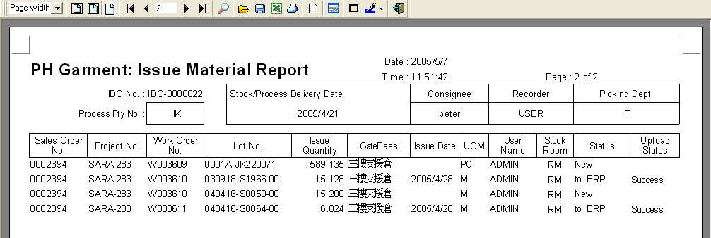
(3). Material Return
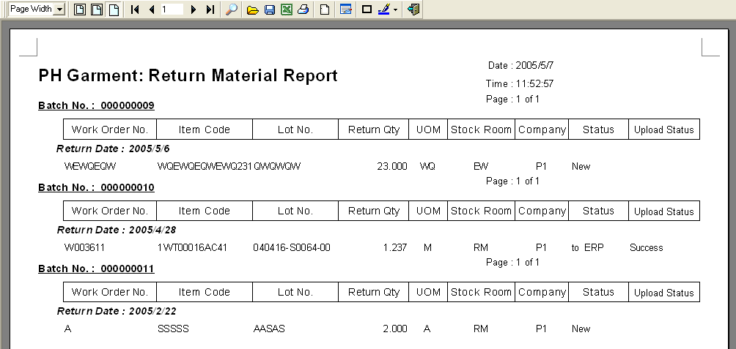

(4). Stock Take
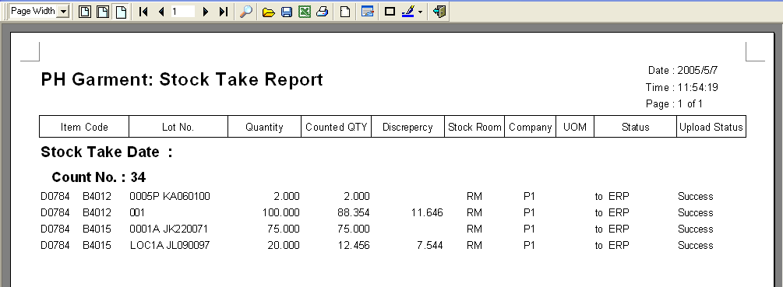

- Public libraries
(1). Print label:
There are 2 barcode printers for printing labels, we have 2 VB class files for the different printers, please refer to the old VB source code in which there are some functions for controlling barcode printer, and some functions for printing label according to inputted parameters.

(2). Process interface files
There are 6 interface files for communication with ERP, we will design a public library for handling these files, so when the interface files changed in the future, we will not change our client side program, but the public library. In this library, we will process retrieve data (APPI1U, APPI2U, APPI5U) and update data (APPI3U, APPI4U, APPI6U), for all the files’ structure, please refer to 3 to review.

